Patricia Caroline (916304)

Day-5-Handson

1)Demonstrate using Service and HttpClient to invoke web service

user.component.html

<div class="some">

<input type="button" value="Get Users" (click)="retrieveAllUser()"/>&nbsp;

<br><br>

<table border="2" cellspacing="0">

<tr>

<th>Photo</th>

<th>Details</th>

</tr>

<tr *ngFor="let item of user.data">

<td><img width="100" [src]="item.avatar"></td>

<td style="text-align: left;">Name : {{item.first_name}} &nbsp;{{item.last_name}}

<br>

Email : {{item.email}}

</td>

</tr>

</table>

</div>

user.component.ts

import { Component, OnInit } from '@angular/core';

import { UserService } from '../user.service';

import { user } from '../user.service';

@Component({

selector: 'app-user',

templateUrl: './user.component.html'

})

export class UserComponent implements OnInit {

public user:any=[];

constructor(private userService:UserService ) { }

ngOnInit(): void {

}

retrieveAllUser() {

this.userService.getAll()

.subscribe(

data => {

this.user= data;

console.log(data);

console.log(this.user);

},

error => {

console.log(error);

});

}

}

user.service.ts

import { Injectable } from '@angular/core';

import { HttpClient } from '@angular/common/http';

const baseUrl = 'https://reqres.in/api/users?page=2';

@Injectable({

providedIn: 'root'

})

export class UserService {

constructor(private http: HttpClient) { }

getAll() {

return this.http.get(baseUrl);

}

}

//Interface for user to handle data

export interface user {

id:number;

email:string;

first_name:string;

last_name:string;

avatar : string;

}

app.module.ts

import { NgModule } from '@angular/core';

import { BrowserModule } from '@angular/platform-browser';

import { AppRoutingModule } from './app-routing.module';

import { AppComponent } from './app.component';

import { ViewempsComponent } from './viewemps/viewemps.component';

import { EditEmpReactiveComponent } from './editemp/edit-emp-reactive.component';

import { EmployeeListComponent } from './employee-list/employee-list.component';

import { EmpInfoComponent } from './emp-info/emp-info.component';

import { UserComponent } from './user/user.component';

import {Routes,RouterModule} from '@angular/router'

import { viewClassName } from '@angular/compiler';

import { QuantityIncrementComponent } from './quantity-increment/quantity-increment.component';

import { FormsModule, ReactiveFormsModule } from '@angular/forms';

import { HttpClientModule } from '@angular/common/http';

const appRoutes:Routes=[{path:"" , component:ViewempsComponent},

{path:"EditEmployees" ,

component:EditEmpReactiveComponent},{path:"QuantityIncrement",component:QuantityIncrementComponent},

{ path: 'edit-emp-reactive/:id', component: EmployeeListComponent},{path:"User",component:UserComponent}]

@NgModule({

declarations: [

AppComponent,

ViewempsComponent,

EmployeeListComponent,

EmpInfoComponent,

UserComponent,

EditEmpReactiveComponent,

QuantityIncrementComponent,

],

imports: [

HttpClientModule,

FormsModule,

BrowserModule,

AppRoutingModule,

ReactiveFormsModule,

RouterModule.forRoot(appRoutes)

],

providers: [],

bootstrap: [AppComponent]

})

export class AppModule { }

OUTPUT:

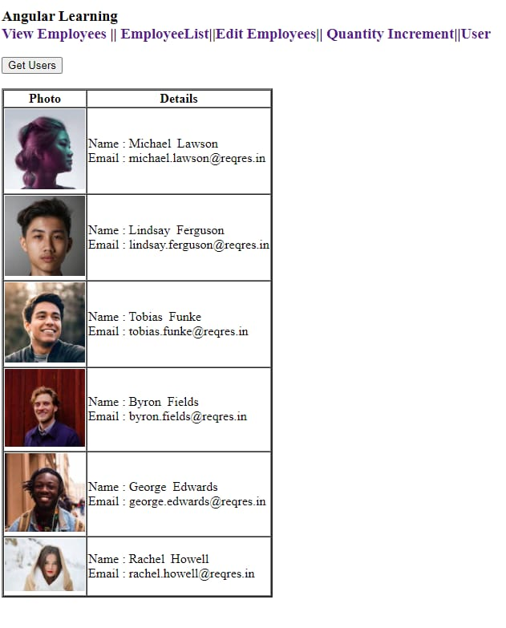

2)Demonstrate end to end testing using Protractor

todo-spec.js

describe('angularjs homepage todo list', function() {

it('should add a todo', function() {

browser.get('https://angularjs.org');

element(by.model('todoList.todoText')).sendKeys('write first protractor test');

element(by.css('[value="add"]')).click();

var todoList = element.all(by.repeater('todo in todoList.todos'));

expect(todoList.count()).toEqual(3);

expect(todoList.get(2).getText()).toEqual('write first protractor test');

// You wrote your first test, cross it off the list

todoList.get(2).element(by.css('input')).click();

var completedAmount = element.all(by.css('.done-true'));

expect(completedAmount.count()).toEqual(2);

});

});

conf.js

exports.config =

{

seleniumAddress: 'http://localhost:4444/wd/hub',

specs: ['todo-spec.js']

};